Excel-01 Homework Assignment Gary Whitney 24/06/2021

All requested changes have been made within the DATA tab of StarterBook.xls

The required Pivots and Charts are located on the following Tabs to the right of the DATA tab

Category Pivot, Country Pivot & Bonus

The Statistical Analysis is in the tab of the same name followed by a Summary Statistics Table tab answering specifically the questions required.

**Conclusion 1**

Music Campaigns have been most likely to succeed, and Food Campaigns have been least likely to succeed.

**Conclusion 2**

The US creates 73.8% of Kickstarter campaigns, followed by GB with 14.6% then CA with 3.5%. Out of the three main countries GB has had the largest proportion of successful campaigns.

**Conclusion 3**

Campaigns created in May and February have been the most successful, Campaigns created in December have been more likely to fail than succeed.

**I have found the following limitations with the data.**

The records for 2009 and 2017 are not for the complete years so can distort reports by month.

The Goal and Pledged data are in ‘local currency’ this distorts and reports that use that information unless it is converted to USD at the relevant rate for the country and date.

There are some outlier successful campaigns where the pledged amount is extremely high compared to the goal.

**Statistical Analysis questions.**

Between the two measures I feel that the Median is more meaningful. This is because of the low quantity of successful campaigns that received an exceptionally high number of backers and the high quantity of unsuccessful campaigns that received no backers at all.

The range of the Z scores for successful campaigns greater than it is for unsuccessful ones, this is primarily because of the large number of unsuccessful campaigns that received no backers whereas successful campaigns always received at least one backer and in some cases received thousands.

**Some other possible tables and/or graphs (On the left hand side of the DATA tab of StarterBook.xls)**

**Goal V Pledged, successful Campaigns by Country USD**

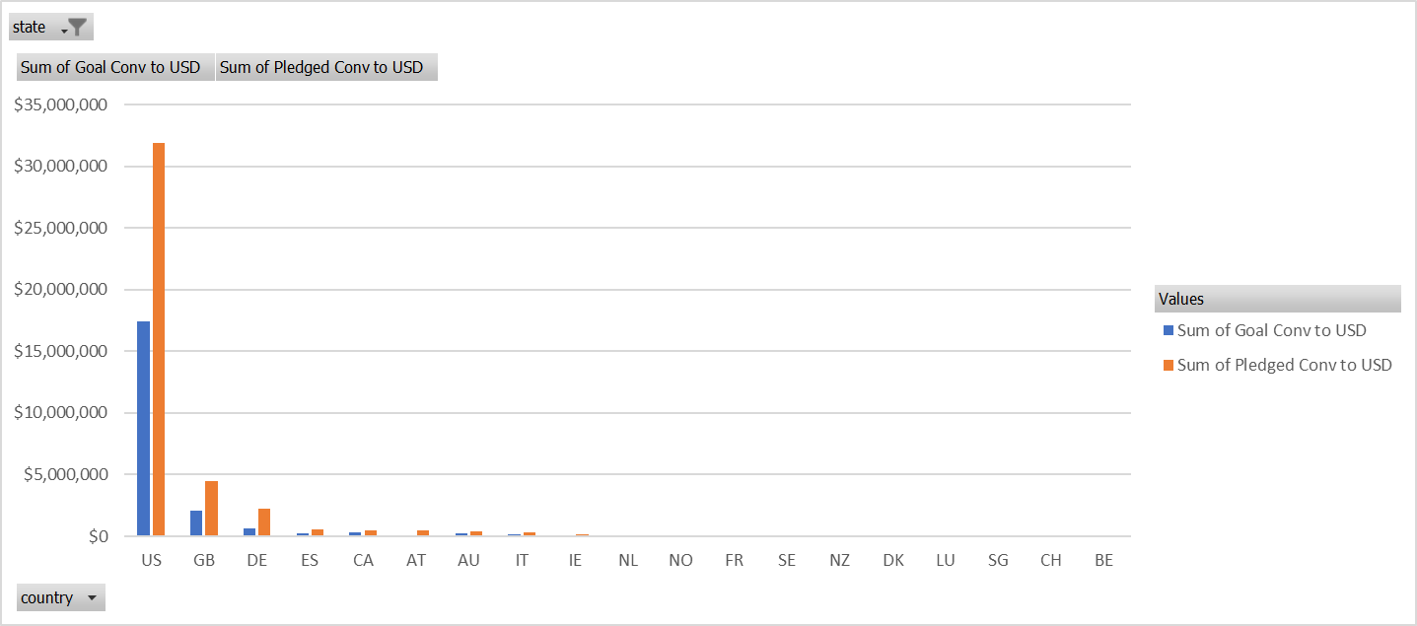

|  |  |  |  |
| --- | --- | --- | --- |
| state | successful |  |  |
|  |  |  |  |
| **Row Labels** | **Sum of Goal Conv to USD** | **Sum of Pledged Conv to USD** |  |
| US | $17,424,292 | $31,910,403 | 83% |
| GB | $2,051,686 | $4,515,152 | 120% |
| DE | $640,101 | $2,235,723 | 249% |
| ES | $224,434 | $558,993 | 149% |
| CA | $360,956 | $503,284 | 39% |
| AT | $69,972 | $498,509 | 612% |
| AU | $262,908 | $378,811 | 44% |
| IT | $145,037 | $325,136 | 124% |
| IE | $121,916 | $165,649 | 36% |
| NL | $67,830 | $79,942 | 18% |
| NO | $37,800 | $58,472 | 55% |
| FR | $30,869 | $38,541 | 25% |
| SE | $27,660 | $34,080 | 23% |
| NZ | $24,150 | $29,526 | 22% |
| DK | $25,440 | $29,316 | 15% |
| LU | $16,125 | $19,118 | 19% |
| SG | $6,660 | $6,752 | 1% |
| CH | $5,450 | $5,767 | 6% |
| BE | $4,463 | $4,815 | 8% |
| **Grand Total** | **$21,547,747** | **$41,397,988** | 92% |

**Country Pivot (2)**

|  |  |  |  |  |  |  |  |
| --- | --- | --- | --- | --- | --- | --- | --- |
| Category | (All) |  |  |  |  |  |  |
|  |  |  |  |  |  |  |  |
| **Count of state** | **Column Labels** |  |  |  |  |  |  |
| **Row Labels** | **successful** | **live** | **failed** | **cancelled** | **Grand Total** | **% of total** | **% Successful** |
| **AT** | **3** | **1** | **2** |  | **6** |  |  |
| **AU** | **19** |  | **41** | **14** | **74** |  |  |
| **BE** | **1** |  | **1** |  | **2** |  |  |
| **CA** | **64** | **1** | **64** | **17** | **146** | 3.5% | 43.8% |
| **CH** | **1** |  | **2** | **3** | **6** |  |  |
| **DE** | **23** |  | **27** | **3** | **53** |  |  |
| **DK** | **4** |  | **6** | **4** | **14** |  |  |
| **ES** | **11** |  | **9** | **1** | **21** |  |  |
| **FR** | **10** | **2** | **10** | **5** | **27** |  |  |
| **GB** | **366** | **8** | **205** | **25** | **604** | 14.7% | 60.6% |
| **HK** |  |  | **2** | **1** | **3** |  |  |
| **IE** | **8** | **1** | **4** | **2** | **15** |  |  |
| **IT** | **7** |  | **19** | **3** | **29** |  |  |
| **LU** | **2** |  |  |  | **2** |  |  |
| **MX** |  | **3** | **8** | **1** | **12** |  |  |
| **NL** | **2** | **1** | **14** | **4** | **21** |  |  |
| **NO** | **2** |  | **5** |  | **7** |  |  |
| **NZ** | **3** |  | **5** | **4** | **12** |  |  |
| **SE** | **7** |  | **9** | **5** | **21** |  |  |
| **SG** | **1** |  |  |  | **1** |  |  |
| **US** | **1651** | **33** | **1097** | **257** | **3038** | 73.8% | 54.3% |
| **Grand Total** | **2185** | **50** | **1530** | **349** | **4114** |  |  |
|  | 2081 |  |  |  | 3788 |  |  |
|  | 104 |  |  |  | 326 |  |  |
| ROW | 31.9% | successful | |  | 7.9% | % of total |  |

**Year Created Pivot**

|  |  |  |  |  |  |
| --- | --- | --- | --- | --- | --- |
| Category | (All) |  |  |  |  |
|  |  |  |  |  |  |
| **Count of state** | **Column Labels** |  |  |  |  |
| **Row Labels** | **successful** | **failed** | **canceled** | **Grand Total** | **% successful** |
| **2010** | **49** | **15** | **1** | **65** | 75.4% |
| **2011** | **136** | **28** | **7** | **171** | 79.5% |
| **2012** | **216** | **60** | **6** | **282** | 76.6% |
| **2013** | **200** | **67** | **7** | **274** | 73.0% |
| **2014** | **474** | **422** | **80** | **976** | 48.6% |
| **2015** | **567** | **527** | **131** | **1225** | 46.3% |
| **2016** | **475** | **376** | **99** | **950** | 50.0% |
| **Grand Total** | **2117** | **1495** | **331** | **3943** |  |

**Bonus (USD)**